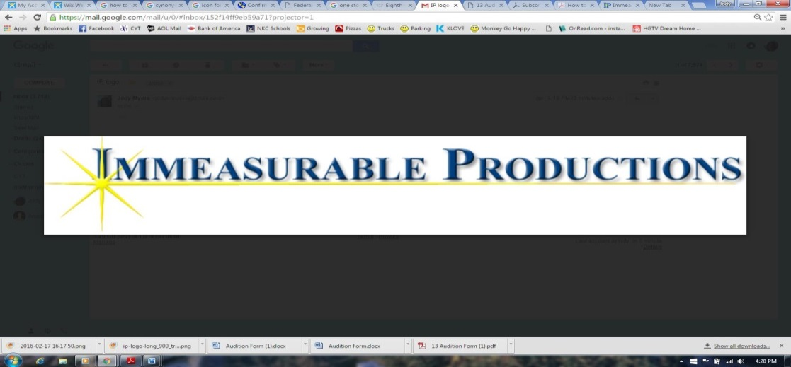**AUDITION FORM:***Thoroughly Modern Millie*

INSTRUCTIONS: *Please* ***print*** *& fill out as much of the requested information below as possible, or circle the appropriate choice where applicable. Bring this form with you to auditions! Write neatly—thank you.*

**AUDITION #**

|  |  |  |  |  |  |  |  |  |  |  |  |  |
| --- | --- | --- | --- | --- | --- | --- | --- | --- | --- | --- | --- | --- |
| *Office Use Only*  LARGELY PRINT YOUR FIRST & LAST NAME: | | | | | | | | | | | | |
| GENDER: Male/ Female | **AGE:** | | | **CURRENT GRADE :** | | | | | | **HEIGHT: ‘ “** | | |
| ADDRESS: | | | | **CITY:** | | | | | **STATE:** | | | **ZIP:** |
| AUDITIONER CELL PHONE: ( ) - - | | | | | **AUDITIONER EMAIL:** | | | | | | | |
| GUARDIAN 1: | | | **PHONE:** ( )- - | | | | | **EMAIL:** | | | | |
| GUARDIAN 2: | | | **PHONE:** ( )- - | | | | | **EMAIL:** | | | | |
| EMERGENCY CONTACT: | | | | | | | **PHONE:** ( ) - - | | | | | |
| ROLE(S) PREFERRED: | | **1.** | | | | **2.** | | | | | **3.** | |

|  |  |  |  |  |  |  |  |  |
| --- | --- | --- | --- | --- | --- | --- | --- | --- |
| PREVIOUS EXPERIENCE: *(Feel free to attach a resume if you have one)* | | | | | | | | |
| SHOW | | **PART** | | | | | | **PRODUCER/COMPANY** |
|  | |  | | | | | |  |
|  | |  | | | | | |  |
|  | |  | | | | | |  |
|  | |  | | | | | |  |
| # OF YEARS OF: | _____BALLET | | _____TAP | _____JAZZ | | | _____OTHER:______________________ | |
| IF YOU’VE TAKEN DANCE, WHERE: | | | | | | | | |
| IF YOU TAKE VOICE, HOW MANY YEARS: | | | | | **VOICE TEACHER:** | | | |
| DO YOU PLAY ANY INSTRUMENTS: Yes No | | | | | | **CAN YOU READ MUSIC?** Yes No Sort Of | | |
| WHICH ONE VOCAL RANGE SUITS YOU BEST: Soprano Mezzo Alto Tenor Bass | | | | | | | | |
| TITLE OF YOUR AUDITION SONG: | | | | | | | | |

**☺ *PLEASE CONTINUE ONTO THE BACK* ☺**

|  |
| --- |
| IF YOU HAVE ANY SPECIAL SKILLS (ESP. GYMNASTICS,) PLEASE LIST THEM HERE: |
| PLEASE LIST ALL CONFLICTS FOR REHEARSALS (12/26-12/31:  Rehearsals are Mon-Fri 9am-6pm, for the ensemble and 9am-9pm for the leads. This does include a 30 min lunch and dinner break. The performances will Saturday, Dec. 31st at 6pm and Sunday, Jan 1st at 2pm & 7pm. |
| HOW DID YOU HEAR ABOUT *Thoroughly Modern Millie* AUDITIONS? Email Website Facebook  f  Word-of-Mouth: If so, from whom? _________________________ Other:________________________________    Poster/Flyer (Located Where:______________________________) |

**If not cast in the role you are wanting, what would be your honest reaction:** *(Choose one)*

* I would be THRILLED to be in the ensemble of this show!
* I would be disappointed, but would still happily participate in the ensemble of the show.
* I would accept ensemble for the show, but not very excitedly.
* I would prefer not to be in the show at all.

**If not cast in “Thoroughly Modern Millie”, would you like to be in the 1920’s themed  
Pre-Show & Entr’ acte Group: “The Moderns”?** *(Choose one)*

* Yes of course! More stage time with fun songs and dances?! Count me in!
* Sure, I think it would be fun group to try.
* No thank you. I would prefer to not be involved at all.

**CAST MEMBER/PARENT CONTRACT**

Please read this with your guardian for you both to understand what is expected during an Immeasurable Productions show:

* If cast, I commit to paying the $195.00 production fee for “Thoroughly Modern Millie”, or $100 production fee for   
  “The Moderns”, due in full on Dec. 26th unless previous arrangements have been made ahead of time.
* Cast Members are to provide their own costumes for the production which must be approved by the staff.
* If cast in a lead, I understand that my lines must be fully memorized, word for word, on Dec. 26th without any excuses.
* Cast Members are to have a good attitude, strong work ethic, and show respect to the cast and IP Staff at all times.

All updates, forms, and information will be posted at [www.IPTheater.com](http://www.IPTheater.com). **Please always check the website first for questions.**

AUDITIONER SIGNATURE:_______________________________________________ DATE:__________________

PARENT SIGNATURE:____________________________________________________ DATE:_________________

*The IP staff is looking forward to your audition! Don’t forget to breathe, relax, and enjoy your audition!   
We’re rooting for you! Break a leg!*